Bahria University,

Karachi Campus



LAB EXPERIMENT NO.

___06___

LIST OF TASKS

|  |  |
| --- | --- |
| TASK NO | OBJECTIVE |
| **01** | Create Department table based on the following design. |
| **02** | Create Employee table based on the following design. |
| **03** | Modify Employee table and add three more columns |
| **04** | Drop Column loc from Department table. |
| **05** | Delete all record from Employee table |
| **06** | Create database Authorization.Add a column ‘Address’ in Starsin table in database Authorization.CREATE TABLE StarsIn ( movieTitle char(30), movieYear int,starName char(30) ); |
| **07** | Solve the Queries given below according to the following tables given below:   1. Apply Not Null Constraint on all columns . 2. Apply primary key constraint in OrderID and customer ID. 3. Apply foreign key constraint on Customer _ID in Order table. 4. Apply check constraint on city (allow Karachi, Islamabad, Lahore only). 5. Set the default value of City as ‘Karachi’. 6. Add CNIC column in Customer table with unique constraint. |
| 08 | Create the following tables given in diagram with constraints (PK-FK relationship). |

Submitted On:

05-04-2023

(Date: DD/MM/YY)

**Task 01:** Create Department table based on the following design.

**Solution:**

create table Department(

dept_no int primary key not null,

dname varchar(100),

loc varchar(100))

**Output:**

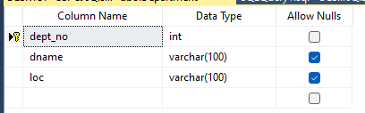

**Task 02:** Create Employee table based on the following design.

**Solution:**

create table Employee(

empno decimal(4,3) primary key not null,

ename varchar(10) not null,

job varchar(9),

mgr decimal(4,1),

hiredate date,)

**Output:**

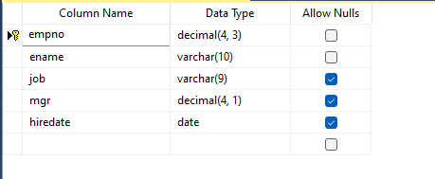

**Task 03:** Modify Employee table and add three more columns

**Solution:**

Alter table Employee Add sal money

Alter table Employee Add comm money

Alter table Employee Add deptno decimal(2,0)

**Output:**

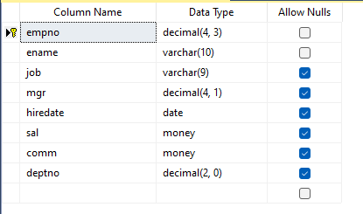

**Task 04:** Drop Column loc from Department table.

**Solution:**

alter table Department

drop column loc

**Output:**

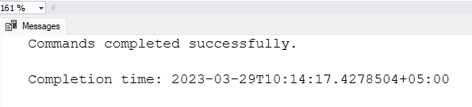

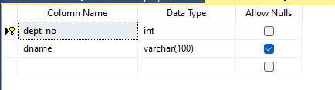

**Task 05:** Delete all record from Employee table

**Solution:** delete from Employee

**Output:**

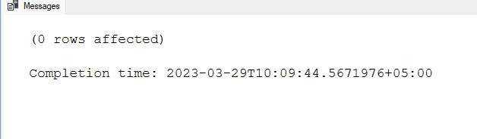

**Task 06:** Create database Authorization

Add a column ‘Address’ in Starsin table in database Authorization.

**Task 06:**CREATE TABLE StarsIn ( movieTitle char(30), movieYear int,starName char(30) );

**Solution:**

create table Starsin (

movieTitle char(30),

movieYear int,

starName char(30) )

**Output:**

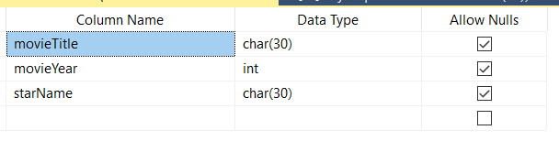

**Task 07:** Solve the Queries given below according to the following tables given below:

* **Apply Not Null Constraint on all columns .**
* **Apply primary key constraint in OrderID and customer ID.**
* **Apply foreign key constraint on Customer _ID in Order table.**
* **Apply check constraint on city (allow Karachi, Islamabad, Lahore only).**
* **Set the default value of City as ‘Karachi’.**
* **Add CNIC column in Customer table with unique constraint.**

**Solution:**

create table Orders(

Order_ID int not null primary key,

Customer_ID int not null ,

Order_Details Varchar(100),

Order_Date date not null,

Required_Date date not null,

foreign key(Customer_ID) references Customers(Customer_ID),)

create table Customers(

Customer_ID int not null primary key,

FirstName varChar(30) not null,

LastName varChar(30) not null,

City varChar(100) not null default 'Karachi',

Address varChar(50) not null,

constraint check_City check(city in ('Karachi','Islamabad','Lahore')))

alter table Customers

add CNIC varchar(30) unique

**Output:**

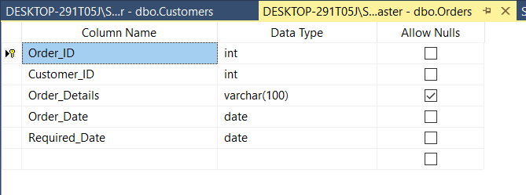

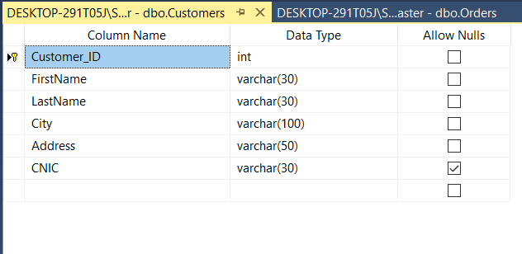

**Task 08:**  Create the following tables given in diagram with constraints (PK-FK relationship).

**Solution:**

create table Product(

maker varchar(10) not null,

model varchar(50) not null primary key,

type varchar(50) not null,)

create table Laptop(

code int not null primary key,

model varchar(50) not null,

speed smallint not null,

ram smallint not null,

hd real not null,

price money,

screen tinyint not null,

foreign key (model) references Product(model))

create table PC(

code int not null primary key,

model varchar(50) not null,

speed smallint not null,

ram smallint not null,

hd real not null,

price money,

cd varchar(10) not null,

foreign key (model) references Product(model))

create table Printer(

code int not null primary key,

model varchar(50) not null,

color char(1) not null,

type varchar(10) not null,

price money,

foreign key (model) references Product(model))

**Output:**



